Instruction Details and Hints for COMPUMAG 2021
Two-page Digests Preparation

First A. Author^{1,2}, Second B. Author, Jr.², and Third C. D. Author^{3,4}, Fellow, IEEE

¹National Institute of Standards and Technology, Boulder, CO 80305 USA, xxx@yyy.zz
²Physics Department, University of Colorado, Boulder, CO 80309 USA, xxx@yyy.zz
³MMM Department, Colorado School of Mines, Golden, CO 80401 USA, xxx@yyy.zz
⁴National Institute for Materials Science, Tsukuba, Ibaraki 305, Japan, xxx@yyy.zz

These instructions give you guidelines for preparing the two-page short paper for the 23rd International Conference on Computation of Electromagnetic Fields (Compumag 2021), which will be held on 16 – 20 January 2022 in Cancun, Mexico. The general layout is almost identical to the standard template of the IEEE Transactions on Magnetics, except that the short papers are limited to two pages. You should use this document as a template for preparing your contributions. You may also download a Template for IEEE Transactions on Magnetics (Revised May 2015) from http://www.ieee.org/publications_standards/publications/authors/author_templates.html. Do not use older versions or versions used at Compumag conferences before Montreal 2015. Accepted short papers will be included in the book of conference proceedings. Papers presented at the conference will be considered for publication in the IEEE Transactions on Magnetics after a second peer-review process. Please carefully follow the instructions contained in this document in order to ensure legibility and uniformity of short papers. To qualify for the conference, the Abstract must clearly state the novelty of the work regarding the numerical computation of electromagnetic fields.

Index Terms—About four key words or phrases in alphabetical order, separated by commas. For a list of suggested keywords, go to http://www.ieee.org/documents/taxonomy_v101.pdf.

T

Introduction
his document is a template for Microsoft Word2010. The electronic version can be downloaded from the conference website http://www.compumag2021.com/.

General Layout of the Two-Page Short Paper
Please prepare the camera–ready copy on a regular size paper (8.5 in x 11 in = 21.6 cm x27.9 cm) or A4 paper (21.0 cm x 29.7 cm). The short paper should be prepared in double-column format, except for the title and the abstract, as shown above. The total text height should be 9.6 in (24.4 cm). The total width should be 7.2 in (18.3 cm) with a separation of 0.2 in (0.5 cm) between the columns. Please provide a top margin of 0.7 in (1.8 cm) and a left margin of 0.65 in (1.65 cm). Paragraphs follow the indented paragraph format with left and right justification. Use 0.36 cm for paragraph indentation. Do not leave space between the paragraphs.The required line spacing within each paragraph is ‘Multiple’ at ‘1.05’ (rather than ‘Single’).
Please number section headings with Roman numerals and center them in the column. The spacing before and after the section headings should be 12 pt and 4 pt, respectively. Please number the subheadings with alphabetical letters. The spacing before and after the subheadings is 6 pt and 3 pt, respectively. The indentation for subheadings is 0.1 in (0.25 cm).

Type and Size of Fonts
Please use Times New Roman typeface and follow the type size specified in Table I as closely as possible. If you use nonstandard fonts for special symbols, please embed them in the PDF (export option).
TABLE I
Types Sizes For Camera-Ready Papers
Item | Type Size  (points) | Appearance
Title | 17 | Bold
Author’s Name | 11 | Regular
Author’s Affiliations, mailing address, and E-mail | 10 | Regular
Abstract | 9 | Bold
Section Titles | 10 | Small capitals, centered in column, Roman numerals
Subheadings | 10 | Italics, alphabetical numerals
Main Text | 10 | Regular
Subscripts and Superscripts in the Main Text | 8 | Regular
Equations | 10 | Regular
Figure Captions | 8 | Regular, centered in column, Arabic numerals
Table Captions | 8 | Small capitals, title case, centered in column, Roman numerals
Table Name/Description | 8 | Small capitals, title case, centered in column, Roman numerals
Table Text | 8 | Regular
Subscripts and Superscripts in Table Text | 6 | Regular
References | 8 | Regular
No vertical lines in table. Statements that serve as captions for the entire table do not need footnote letters. A longer description of the table would go here.

Useful Hints

Abbreviations and Acronyms
Define abbreviations and acronyms the first time they are used, even after they have been defined in the abstract. Commonly acceptable abbreviations such as IEEE, SI, MKS, ac, and dc do not have to be defined. Do not use abbreviations in the title unless they are unavoidable.

Figures and tables
Place figures and tables in the middle of columns. Figure captions should be left justified below the figures; table captions should be centered above the tables. Please use words rather than symbols to label the axes. As an example, write the quantity “Magnetization,” or “Magnetization, M,” not just “M.” Put units in parentheses. Do not label axes only with units. As in Fig. 1, for example, write “Magnetization (A/m)” or “Magnetization (A·m⁻¹),” not just “A/m.” Do not label axes with a ratio of quantities and units. For example, write “Temperature (K),” not “Temperature/K.” Multipliers can be confusing. Write “Magnetization (kA/m)” or “Magnetization (10³A/m),” not “Magnetization (A/m×1000)” because the readers would not know whether the top axis label in Fig. 1 meant 16000 A/m or 0.016 A/m.
Figure labels should be legible, approximately 8 to 12 point type when reduced to column width.Note that “Fig.” is abbreviated. There is a period after the figure number, followed by two spaces.
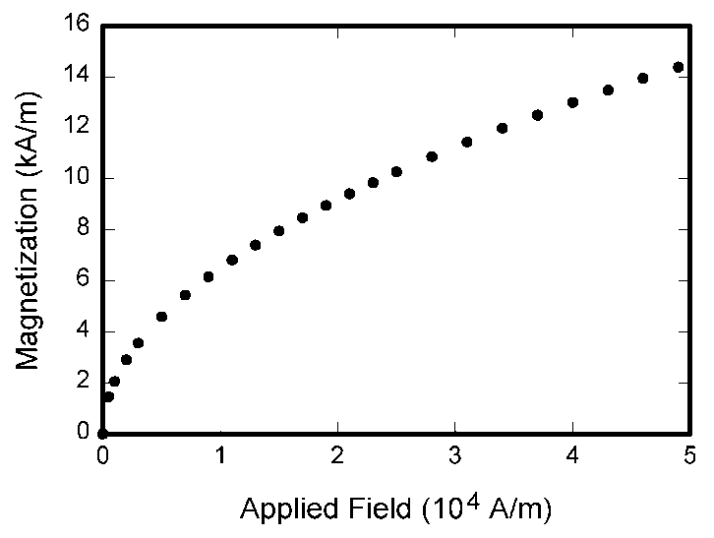
Fig. 1. Magnetization as a function of applied field.

Equations
Number equations consecutively with equation numbers in parentheses flush with the right margin, as in (1). To make your equation more compact, you may use the solidus (/), the exp function, or appropriate exponents. Use parentheses to avoid ambiguities in denominators. Punctuate equations when they are part of a sentence, as in
(1)
Be sure that the symbols in your equation have been defined before the equation appears or immediately following. Refer to “(1),” not “Eq. (1)” or “equation (1)” except at the beginning of a sentence: “Equation (1) is…”. Please confine equations to one column width and break equations at appropriate algebraic symbols.

Units
Use either SI (MKS) or CGS as primary units. SI units are strongly recommended. Avoid combining SI and CGS units, such as current in Ampere and magnetic field in Oersted. If you must use mixed units, clearly state the units for each quantity in an equation.

Conclusion
A conclusion section is not required. Although a conclusion may review the main points of the paper, do not replicate the abstract in the conclusion. A conclusion might elaborate on the importance of the work or suggest applications and extensions.

References
Number citations consecutively in square brackets [1]. The sentence punctuation follows the brackets [2]. Multiple references [2], [3] are each numbered with separate brackets [2]-[3]. When citing a section in a book, please give the relevant page numbers [2]. In sentences, refer simply to the reference number, as in [3]. Do not use “Ref. [3]” or “reference [3]” except at the beginning of a sentence. Papers that have not been published should be cited as “unpublished” [4]. Papers that have been submitted for publication should be cited as “submitted for publication” [5]. Papers that have been accepted for publication but not yet specified for an issue should be cited as “to be published” [6]. Please give affiliations and address for private communications [7]. Use a space after authors’ initials. Capitalize only the first word in a paper title, except for proper nouns and element symbols.
Adequacy of references is one of many factors to be considered by COMPUMAG paper reviewers. The editors of Magnetics Society journals and conference proceedings are opposed to all forms of bibliometric (impact factor) manipulation. Do not include gratuitous or irrelevant references to articles published in Magnetics Society journals. In the same spirit, the editors expect authors to not excessively cite their own prior publications.

Language
The use of grammar and spelling checker is strongly recommended. It is also suggested that you have the short paper proofread by a native English-speaking colleague if your native language is not English.

References
- G. Eason, B. Noble, and I. N. Sneddon, “On certain integrals of Lipschitz-Hankel type involving products of Bessel functions,” Phil. Trans. Roy. Soc. London, vol. A247, pp. 529-551, Apr. 1955.
- J. Clerk Maxwell, A Treatise on Electricity and Magnetism, 3rd ed., vol. 2. Oxford: Clarendon, 1892, pp. 68-73.
- I. S. Jacobs and C. P. Bean, “Fine particles, thin films and exchange anisotropy,” in Magnetism, vol. III, G. T. Rado and H. Suhl, Eds. New York: Academic, 1963, pp. 271-350.
- T. L. Gilbert, Formulation, Foundations and Applications of the Phenomenological Theory of Ferromagnetism, Ph.D. dissertation, Illinois Inst. Tech., Chicago, IL, 1956, unpublished.
- S. O. Demokritov, “Brillouin light scattering spectroscopy of magnetic nanostructures,” IEEE Trans. Magn.,submitted for publication.
- E.H. Miller, “A note on reflector arrays,” IEEE Trans. Antennas Propagat., to be published.
- C.J. Kaufman, Rocky Mountain Research Laboratories, Boulder, CO, private communication, 2014.

